DSYS601
Understanding REST and JSON

Index:

Item | Description | Page
1 | Introduction | 2
2. | Foundation Topics | 3
2.1 | REST-BASED APIs | 3
3 | REST-Based APIs and HTTP | 7
3.1 | Introduction | 7
3.2 | Software CRUD Actions and HTTP Verbs | 7
3.3 | Using URIs with HTTP to Specify the Resource | 9
3.4 | Example of REST API Call to DNA Centre | 11
4. | Data Serialisation and JSON | 13
4.1 | Introduction | 13
4.2 | The Need for a Data Model with APIs | 14
4.3 | Data Serialisation Languages | 16
4.4 | Interpreting JSON | 18
5. | Module Review | 23
6. | Quiz | 24

1. Introduction:

Automation software is used to automate and program networks.
The software can analyse the data as variables, and make decisions based on this.
It can take action to change configurations, or report the state of the network.

Different automation functions reside on different devices:
- The Engineer’s workstation
- A server
- A controller
- The various network devices themselves.

All these components need to have well defined protocols to communicate between the software components.

This module focusses on two protocols used to allow automation software to communicate:
- APIs that follow a style called “Representational State Transfer”
These “RESTful APIs follow a particular set of software rules.
- JavaScript Object Notation (JSON).
This is a method of transferring data over the network.
This includes their variable names, values, and data structures.

2. Foundation Topics:

2.1 REST-BASED APIs:

2.1.1 Introduction:

Applications use APIs to communicate with each other.
The applications have to agree on the variables and data structures to use.
Choices are then made based on the values of the variables.
APIs allow the applications to run on different physical machines.

APIs use client/server architecture.
A server application creates an API, and client applications use the API.
Developers use APIs with their software allowing other applications to use the data.
As a client application, useful time is spent looking for APIs to perform tasks.
This reduces the amount of code they need to write.
Additionally, pre-built libraries can be used to save time writing existing code.

Several types of APIs exist, each with different conventions.
Networking in general and Cisco in particular, use REST.
This is “Representational State Transfer” (REST).
This makes it very popular with network automation code and applications.

2.1.2 REST-Based (RESTful) APIs:

Introduction:

REST APIs follow a set of rules.
It has six attributes defined by its creator Roy Fielding:

1. Client/Server architecture.
Remember
2. Stateless operation
3. Clear statement of cacheable/uncacheable
4. Uniform interface.
5. Layered
6. Code-on-demand.

The first three attributes are the heart of how a REST API operates.
Let’s look at them in more depth…

Attribute 1 - Client/Server Architecture:

REST applications use a Client / Server architecture.
The developer creates the API to run on a server (or Router, or Switch, etc.)
Applications can interact with it by making an API call.
This “REST client” executes code to send data from the client to the server.

1. Below, the REST client executes a REST API call.
This generates a message that is sent to the REST server.

2. The REST server (RHS) processes the request and decides how to reply.

3. The REST server sends a reply back to the client.
This has the appropriate data structure and variables in the reply.

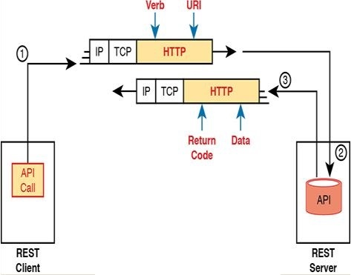
Typically: JSON
Possibly: XML
Maybe: YAML (if using Ansible)
E.g.:
Python or
Postman

Figure 1 - Client/Server Operation with REST

Note: Above, HTTP is used as the transport mechanism.
Often, REST APIs use HTTPS instead.
The use of HTTP exclusively is not a requirement of an API to be RESTful.

Attribute 2 - Stateless Operation:

REST doesn’t record and use information about an API exchange for subsequent exchanges. Each API request and reply doesn’t use any other past history.
In comparison, TCP is stateful, whereas UDP is stateless.
TCP requires the endpoints to initialise variables at each end.
These variables update as messages are sent.
For example, TCP sequence and acknowledgement numbers manage data flow.

Attribute 3 - Cacheable (or Not):

Consider what happens when a website is browsed.
The browser loads a page of graphics, text, etc.
Some objects don’t change between pages, so it’s beneficial to download images.
These images can be cached locally, saving bandwidth.
In this case, the server marks the objects as “cacheable”.
Other items, like product lists, etc, shouldn’t be cached.

REST APIs require that any resource requested via an API call should have a method to mark the resource as cacheable or not.
This improves performance, just like with the website example above.
Cacheable resources are marked with a “timeframe” (lifetime).
This lets the client know when to ask for a new copy of the resource again.

2.1.3 Background: Data and Variables:

Introduction:

The next topics discuss programming language variables.
Specifically, the concept of “simple”, “list”, and “dictionary” variables are discussed.

Simple Variables:
Applications process data which is typically stored in simple variables.
When the application makes a request to an API, data is returned as a response.
This response needs to be stored (appropriately) in variables.
The variables can be used to perform sequence, selection, and iteration.
A variable is a name or label that has a value assigned to it.

Python is a popular programming language used to work with API calls.
Below, the Python program begins with a comment (triple single quotes).
Next, four variables are assigned values.
Finally, the output is printed:

‘‘‘
Sample program to multiply two numbers and display the result
‘‘‘
x = 3
y = -4
z = 1.247
heading = “The product is “
print(heading, x*y)

The product is -12

These are simple variables, as they only hold a single value.
The simple variables above hold different “types” of data, including:
- Unsigned integer
- Signed integer
- Floating point number
- Text

Python “List” and “Dictionary” Variables:

Sometimes, programs need more than simple variables with single values.
These new variable types are called “complex data structures”.
In this case, the variable can hold multiple values.

Python “List” (JSON “Array”):

E.g.: Python uses a list to hold multiple values of the same “type”.
This can be used to hold a list of IPv4 addresses of devices in your network.
Alternatively, it can hold information on a list of interfaces on a given device.
Below is a simple Python list – the comment is preceded with a hash (#):

# Variable list1 is a list in python (called an “Array”)
list1 = [“G0/0”, “G0/1”, “G0/2”]

A list can be graphically represented as shown below.
This is a variable called “list1”, which has three elements (g0/0, g0/1, and g0/2):

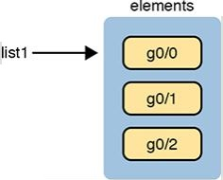

Figure 2 - The List Data Structure in Python

- In JSON, the array is:
- An ordered list of values.
- Denoted by square brackets [ ].
- Elements in an array can be of any data type
- Elements are accessed by their index, starting from 0.

E.g.:
[1, 2, "three", true, null]

Python “Dictionary (JSON “Object”):

Python can use another variable called a “Dictionary”.
This can contain multiple variables and values.
Each variable can be either a simple or complex data structure.
The variable is called the “key”, and the content is called the “value”.
Below is a simple Python dictionary holding interface configuration parameters:

# Variable dict1 is a dictionary in python (called an “Associative Array”)
dict1 = {“config_speed”:“auto”, “config_duplex”:“auto”, “config_ip”:“10.1.1.1”}

A dictionary can be graphically represented as shown below.

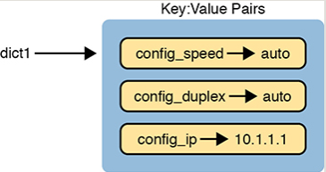

Figure 3 - The Dictionary Data Structure in Python

Data structures can get more complex, and they can be nested.
E.g.: a single variable could be a list of dictionaries, each with multiple key:value pairs.

- In JSON, the object is:
- An object is an unordered collection of key-value pairs.
- Denoted by curly braces { }.
- Each key in an object must be a string, and each value can be of any data type.

E.g.:
{
"name": "John",
"age": 30,
"isStudent": false,
"grades": [90, 85, 92]
}

3. REST-Based APIs and HTTP:

3.1 Introduction:

APIs exist to allow programs to exchange data.
Some APIs can act as an interface between two programs on a common computer.
The communications exist within a single operating system.
Other APIs run on a different machine to the applications.
The API supports specific networking protocols.
Many REST-based APIs use either HTTP or HTTPS.

The reason HTTP is used is because its logic matches the needs of REST APIs.
Furthermore, HTTP uses the same principles as REST:
- It operates using a Client/Server model.
- It uses a stateless operational model.
- It includes headers that mark objects as cacheable or not.

HTTP also include verbs (doing words) that are similar to those used by REST APIs.
The next section explains programming terminology, how HTTP verbs match REST API tasks, and how REST APIs use a URI to specify a RESTful request.

3.2 Software CRUD Actions and HTTP Verbs:

CRUD is an acronym for Create, Read, Update, and Delete.
These are the HTTP verbs that describe the primary actions performed in an application.

- Create:
Allows the client to create new instances of variables and data structures on the server.

- Read:
Allows the client to read existing values of variables stored on the server.

- Update:
Allows the client to change existing values of variables stored on the server.

- Delete:
Allows the client to remove existing values of variables stored on the server.

For example, if using a Northbound REST API on a DNA controller, you may want to create a new security policy. This exists as a set of configuration settings on the controller – internally represented as variables. To achieve this, the REST client would use a “Create” action, and use a DNA Centre RESTful API to create variables on the DNA Controller via the DNA Centre REST API.

Other examples include checking the status of the new configuration via a “Read” action, updating (changing) existing values with an “Update” action, and removing the aforementioned security policy completely with a “Delete” action.
HTTP uses verbs that mirror these CRUD actions. HTTP has “requests” and “replies”, where a request is when the client asks the server to do something, and a reply is the returned information from server back to client. Each request/reply lists an action verb in the HTTP request header, defining the HTTP action to take.
The message also includes a URI, used to identify the resource being altered.
As always, the HTTP message is carried in TCP, within IP, with headers and data as shown below:

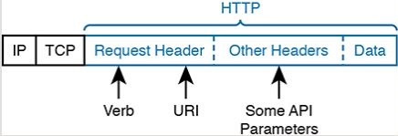
Figure 4 – HTTP verb and URI in an HTTP Request Header

When you open a web browser and click a link, the browser generates an “HTTP GET” request similar to that shown above. This includes the HTTP header (with the “GET” verb, and URI). The resource returned in the reply are the HTML components of a web page, such as text files, images files, and video files.

HTTP works well with REST because its verbs match the actions in the CRUD paradigm. Below is a list of HTTP verbs, and the associated CRUD terms:

Action | CRUD Term | REST (HTTP Verb)
Create new data structures and variables | Create | POST
Read (retrieve) variables, structures, values | Read | GET
Update or replace values of some variable | Update | PATCH, PUT
Delete some variables and data structures | Delete | DELETE

Table 1 – Comparing CRUD actions to REST verbs

REST-Based API Descriptions

REST-BASED API | Description
POST | Creates a resource and returns its URI in the response header
PUT | Creates or replaces a previously modified resource using information in the request body
DELTE | Removes a resource
GET | Retrieves a list of a resource’s URIs
PATCH | Updates a resource using instructions included in the request body

Note: For a full explanation, see “Rest-based APIs” MS-Word document in G:\Professional Development\39. CCNAv7 Recertification\01. Cisco Requirements\02. Study Documents\06. Automation and Programmability\02. Additional Material\6.5 – REST-based APIs

POST: Used to submit data to a resource for processing.
Creates and defines a new resource
Returns a URL for later reference
Creates a resource and returns its URI in the response header.
PUT: Used to update an existing resource with new data.
Used to replace the ENTIRE resource (unlike PATCH).

PATCH: Used to update a portion of an existing resource with new data.
Only replaces SOME of the resource content (unlike PUT).

GET: Used to retrieve data from a resource.
Use in “read-only” mode to return a resource’s contents and data.

DELETE: Used to delete a resource entirely.
Removes a resource

HEAD: Similar to GET, but only returns the headers and not the body of the response.

OPTIONS: Used to retrieve information about the communication options available for a resource.

3.3 Using URIs with HTTP to Specify the Resource:

- Specific HTTP verbs are used to perform CRUD actions.
REST uses the URI to identify which resource the HTTP request acts upon.
For REST APIs, the resource can be any one of many resources defined by the API. Each resource contains a set of related variables, defined by the API and identified by a URI.

- For example, imagine an engineer has created a REST-based API.
A set of resources are identified that will be made available via the API.
The creator creates the URI, and a matching set of variables.
Further, actions are defined that may operate on these variables.
E.g.: Create, Read, Update, and Delete.
Furthermore, documentation is created to list the resources available.
The programmer can read the documentation to build the REST API request.
E.g.:

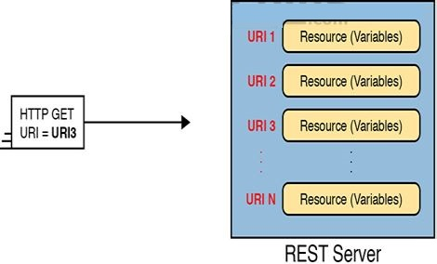

Figure 5 – One URI for each API Resource – a conceptual view

- Above, the URIs are considered as generic values.
Today, engineers need to be able to read API documentation.
From there, they check the URIs in the documentation.
This allows them to understand the meaning of each part of the URI.
Below is a URI specific to the Cisco DNA Centre northbound REST API.

Hostname / Address

HTTPS://dnac.example.com/dna/intent/api/v1/network-device

Path (Resource)
Protocol

Figure 6 – URI structure for REST GET Request

Where:
- HTTPS is the protocol used.
- Hostname or IP Address identifies the host (use hostname if DNS available)
- Path (Resource) is the resources defined and required by the API.

When Cisco created DNA Centre, it created the REST-based northbound interface and chose one URL as shown below. Go to https://developer.cisco.com and search for “Cisco DNA Centre API documentation”.

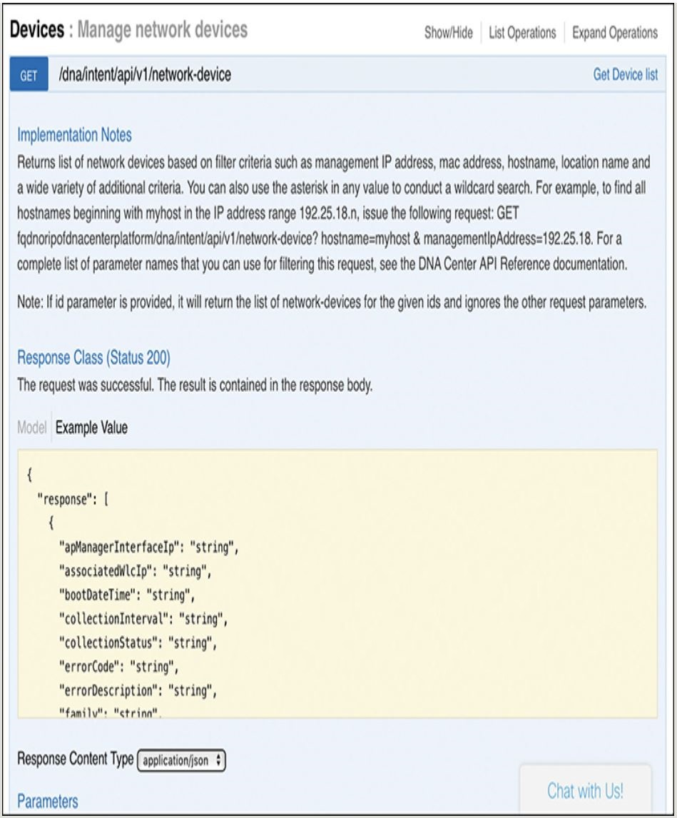

Figure 7 – DNA Centre API Doc page for the Network Device (List) Resource

- Many of the HTTP request messages need to pass information to the REST server. Some of that data is located in the header fields. E.g.: REST APIs use the HTTP header fields to encode the authentication information for REST calls.

Additionally, parameters related to a REST call can be passed as parameters in the URI itself. Below, the URI asks the Cisco DNA Centre for a list of all the known devices. The Cisco DNA Centre returns a dictionary of values for each device. However, you may only want this dictionary of values for just one device. To tell the Cisco DNA Centre which device, add it as a parameter:

Hostname / Address

HTTPS://dnac.example.com/dna/intent/api/v1/network-device?parm1=10.1.1.1

Query (Parameters)
Path (Resource)
Protocol

Figure 8 – Example components of a URI used in a REST API call
3.4 Example of REST API Call to DNA Centre:

This section works through a sample API call.
When working to automate network tasks, you’ll use a program that makes API calls.
Early in the process, you’ll focus on the API data, and ignore the programming.
API development environments allows you to focus on the actual API calls.
Later, generate the code and copy in the details that make the API call.

Below, the API development environment is called “Postman”.
This can be downloaded for free at www.postman.com
Cisco DevNet makes extensive use of Postman in its labs and examples.

The first example shows the Postman app after sending a GET request.
This is sent to a DNA Centre REST API.

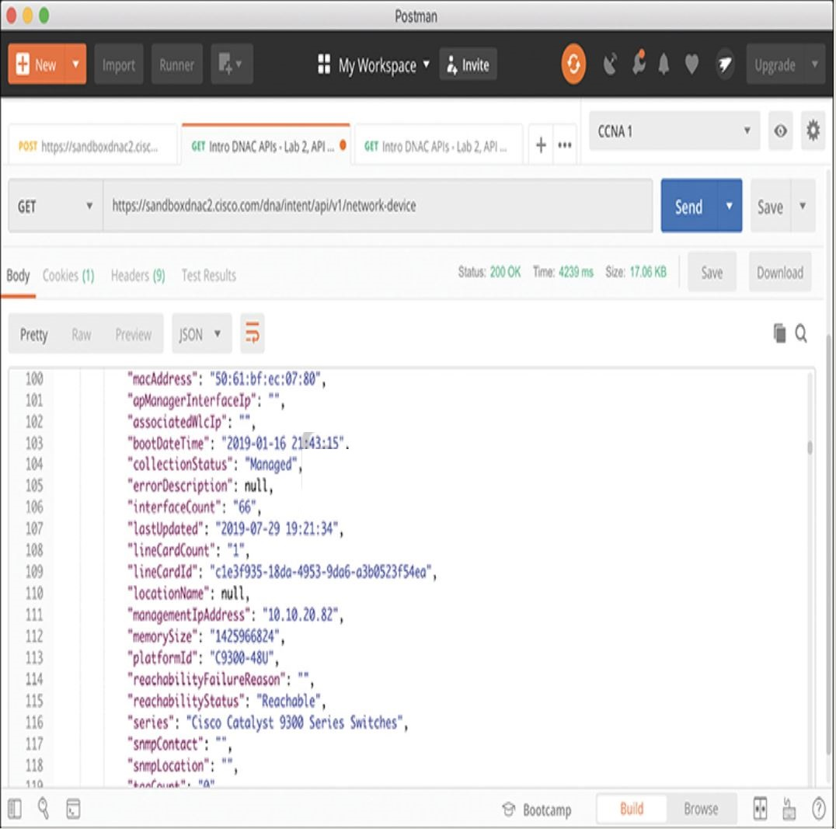

Figure 9 – URI Structure for REST GET Request

Note the following:
- The URI (near the top) lists the hostname as sandboxdnac2.cisco.com
This is an always-on DNA Centre instance supplied by DevNet.

- The resource part of the URI shows the same resource listed in figure 8.
It is asking for details on a specific device.

- The bottom centre of the window shows the returned data.
- The middle right lists the GET response’s status code of 200 (OK).

The returned data is edited (shortened) and shown below.
The text is formatted in an encoding type called JSON.
As can be seen, a large amount of data is returned to the client:

{
“response”: {
“type”: “Cisco Catalyst 9300 Switch”,
“family”: “Switches and Hubs”,
“role”: “ACCESS”,
“macAddress”: “F8:7B:20:67:62:80”,
“hostname”: “cat_9k_1”,
“serialNumber”: “FCW2136L0AK”,
“softwareVersion”: “16.6.1”,
“uptime”: 17 days, 22:51:04.26,
“interfaceCount”: “41”,
“lineCardCount”: “2”,
“managementIpAddress”: “10.10.22.66”,
“series”: “Cisco Catalyst 9300 Series Switch”,
“softwareType”: “IOS-XE”
}
}

Figure 10 – JSON Output from a REST Call

Postman helps work out the particulars of each API call.
It can save the details, and allow you to share with others.
Once successfully completed, it can generate code to add to your program.

You should now have a good foundational knowledge of REST APIs.
By learning some skills, and using the API documentation, you could now experiment with, and try to make, REST API calls.
For many of the calls, the data will be returned as text (often in JSON format).
The next section examines the meaning of that text.

4. Data Serialisation and JSON:

4.1 Introduction:

Data serialisation is the process of converting complex data structures, such as objects or data arrays, into a format that can be easily stored, transmitted, or reconstructed. In other words, it involves converting the state of an object or a data structure into a sequence of bytes or a string that can be easily transmitted over a network or saved to a file. The reverse process, where serialised data is converted back into its original form, is called deserialisation.

There are several data serialisation languages used with REST APIs.
Each one provides methods of using text to describe variables.
The goal is to send text over a network, or store the data in a file.
These languages give us a way to represent variables with text.
This is as opposed to representing it in a programming language.

Each data serialisation language allows API servers to return data such that the API client can replicate the same variable names and data structures found on the server. To describe the data structures, the language includes special characters and conventions to represent list variables, dictionary variables, and other complex data structures.

The following section examines the concept of data serialisation languages.
If focusses on the one mentioned in CCNA, namely JSON.

4.2 The Need for a Data Model with APIs:

Variable need to be transferred from a program on a server, to a client program.
Below demonstrates a non-networking example used to identify challenges with copying variable values from one device to another.

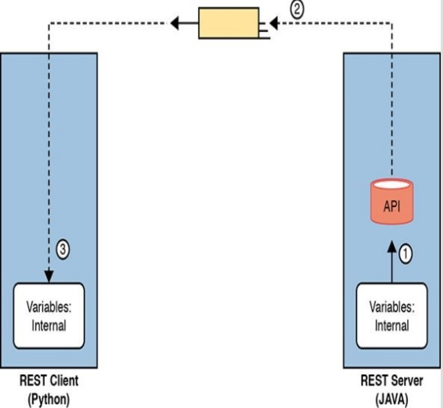

Figure 11 – Broken Concept: Exchanging Internal Representations of Variables

Consider the flow, and steps required to transfer data in this manner.
A REST client sits on the LHS, and asks for a resource from the server (RHS).
In REST, a resource is a set of variables, defined by the API.
The REST server has to return a set of variables to the REST client.
Here are the steps required to perform this task:

1. The REST server receives the REST request from the Client.
It takes a copy of the stored variables and places them in its RAM.

2. The REST API code creates a REST reply and sends it over the network.
This places an exact replica of what the REST server has in RAM.

3. The REST client is a Python application.
It takes the REST reply message, and stores it into its own RAM.
This is its attempt to have a copy of the variables, data, and data structure.

Unfortunately, this won’t work very well.
The REST client cannot store the variables in the same way that the server has it.
First, programs written in different languages have different storage conventions.
There is no standard for internal variable storage across languages.
Even programs using different revisions have different storage conventions.

To overcome this, applications need a standard method of representing variables for transmission and storage outside the program that created them. Data serialisation languages provide this function.

Below, an appropriate process is provided.

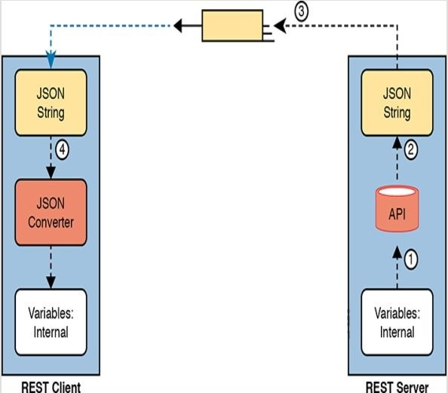

Figure 11 – Appropriate Concept: Exchanging Internal Representations of Variables

1. The REST server collects the internally represented data and sends it to the API code.

2. The API converts this internal representation to a data model that represents these variables (with JSON shown above).

3. The server sends the data model in JSON format via messages across the network.

4. The REST client takes the data and converts the JSON formatted data into variables in the native format of the client.

At the end of the process, the REST client has equivalent variables to the ones requested of the REST server in the API call. The final step, to convert from the data serialisation language to the native format, can be as simple as a single line of code!

Finally, note that whilst data serialisation languages like JSON allows applications to exchange variables over a network, applications can also store the data in JSON format (E.g.: BSON).

4.3 Data Serialisation Languages:

When working with network automation, you will user several serialisation and data modelling languages. The current CCNA only discusses JSON, however there are alternatives worth a “quick look”. These alternatives exist to meet different needs over the last few years.

4.3.1 JSON:
- This is “JavaScript Object Notation”.
Its purpose is to strike a compromise between human & machine readability.
By learning just a few rules, it is possible to read most JSON data.
JSON makes it possible for programs to convert JSON text into its variables.
This makes it useful for exchanging data between applications using APIs.
JSON is defined in IETF RFC 8259.
For more details, go to: www.json.org

4.3.2 XML:
- In the 1990’s, web browsers started using HTML to create web pages.
HTML defined how to add text, video, graphics, etc. to the document.
The “markup” included formatting details, etc.
E.g.: font types, sizes, colours, hyperlinks, etc.

- “Extensible Markup Language” (XML) was born from HTML.
Web pages became more dynamic.
A markup language that could define data variables was required.
XML is a markup language that has features to define variables and data structures.
XML has grown beyond this original need.
Today, it is used as a general data serialisation language.

- Compared to JSON, XML is less “human-readable”.
Like HTML, XML uses tags to delineate variables and structures.
E.g.:

<?xml version = “1.0” encoding = “UTF-8”?>
<root>
<response>
<family>Switches and Hubs</family>
<hostname>cat_9k_1</hostname>
<interfaceCount>41</interfaceCount>
<lineCardCount>2</lineCardCount>
<macAddress>F8:7B:20:67:62:80</macAddress>
<managementIpAddress>10.10.22.66</managementIpAddress>
<role>ACCESS</role>
<serialNumber>FCW2136L0AK</serialNumber>
<series>Cisco Catalyst 9300 Series Switches</series>
<softwareType>IOS-XE</softwareType>
<softwareVersion>16.6.1</softwareVersion>
<type>Cisco Catalyst 9300 Switch</type>
<upTime>17 days, 22:51:04.26</upTime>
</response>
</root>

4.3.3 YAML:
- This expands to: “YAML Ain’t Markup Language” - a recursive acronym.
Unlike XML, YAML doesn’t attempt to define the markup details.
Instead, YAML focusses on the data model (structural) details.
It attempts to be clean and simple.
It is the easiest language to read.

- Ansible (an automation tool) makes extensive use of YAML.
Below is an example of using a YAML file as an Ansible playlist.
Note that YAML denotes variables in double curly brackets: {{ }}

---
# This comment line is a place to document this Playlist
- name: Get IOS Facts
hosts: mylab
vars:
cli:
host: “{{ ansible_host }}”
username: “{{ username }}”
password: “{{ password }}”
tasks:
- ios_acts:
gather_subset: all
provider: “{{ cli }}”

4.3.4 Summary of Data Serialisation:

- Below is a reference table that summarises serialisation languages.

Acronym | Name | Origin | Purpose | Human Readability
JSON | JavaScript Object Notation | JavaScript language. | General data modelling and serialisation | Average
XML | Extensible Markup Language | www Consortium (W3C.org) | Data-focussed text markup that allows data modelling. | Hardest
YAML | YAML Ain’t Markup Language | YAML.org | General data modelling. | Easiest

- YAML is a superset of JSON
YAML supports comments, whereas JSON doesn’t
YAML supports date and timestamp data structures, JSON doesn’t
YAML is easier to read (human format) than JSON
YAML is better for applying infrastructure as code and CI/CD pipelines
See the YAML vs JSON document.

- JSON is lighter and more compact than YAML, making it faster over HTTP
JSON works well (Parsing / Serialisation) with languages like Python
JSON works well with Web APIs (over HTTP) – good for logging and data analysis.

4.4 Interpreting JSON

4.4.1 Introduction:

- CCNA 200-301 has an exam topic that mentions JSON.

6.7 Interpret JSON encoded data

- This involves understanding the key:value pairs.
Below, you see a key of “hostname”, and a value of “Interfaces”:

{
“R1”: [“GigabitEthernet 0/0”, “GigabitEthernet 0/1”, “Serial 0/0/0”],
“R2”: [“GigabitEthernet 0/0”, “GigabitEthernet 0/1”, “Serial 0/0/0”],
}

- More work is required to analyse JSON data, understand data structures (including objects, lists, and key:value pairs). To understand these concepts, let’s look at the basic rules of JSON.

4.4.2 Interpreting JSON Key:Value Pairs

- First, let’s look at some terms, and an example:

1. Key:Value Pair:
Every colon (:) identifies a key-value pair where the key precedes the value.

2. Key:
This is text, inside double quotes, before the colon.
It is used to reference the value.

3. Value:
The item after the colon that holds the value. It can be:
- Text (listed in double quotes).
- Numeric (Listed without quotes).
- Array (multiple values of different types – see below).
- Objects (a special value – see below).

4. Multiple Pairs:
Where there are multiple key:value pairs, separate them with a comma.

- Below is an example of JSON data.
It describes three key:value pairs.

{
“1stbest”: “Messi”,
“2ndbest”: “Ronaldo”,
“3rdbest”: “Pele”
}

- Each colon defines the key-value pair.
Keys are “1stbest”, “2ndbest”, and “3rdbest”.
Their values are “Messi”, “Ronaldo”, and “Pele” respectively.
Above, all values are text, as they are enclosed in double quotes.

- For other special characters, note the commas and curly brackets.
Any key:value followed by a comma means another key:value pair follows.
Everything in curly brackets represent a single JSON object.
JSON files and data, exchanged over an API, exist as a JSON object.
They will all start with a ‘{‘, and end with a ‘}’.

4.4.3 Interpreting JSON Objects and Arrays:

- Data structures can extend past simple key:value pairs.
JSON uses “objects” and “arrays” to afford flexibility in data types.

Note: Python works well with JSON; it has the ability to easily convert the following:

JSON | Direction | Python
Object |  | Dictionary
Array |  | List

- An array is a series of values, not key-values (of any type).
- An object acts as a dictionary, holding values of any type.

- Consider this set of rules about how to understand JSON objects and arrays:

1. { } = Object:
A series of key:value pairs enclosed in curly brackets is an object.
Python will take this and convert it to a Python Dictionary (associative list).

2. [ ] = Array:
A series of values (not key:value pairs) enclosed in a pair of square brackets.
Python will take this and convert it to a Python List.

3. Key:value pairs inside objects:
All key:value pairs inside an object conforms to the rules in 4.4.2 above.

4. Values inside arrays (AKA Python “lists”):
All values conform to the earlier rules for formatting values.
E.g.: double quotes around text, no quotes around numbers, etc.

- Below is an example of JSON code.
It consists of a single JSON array.
Notice that the values are within square brackets.
Python will take this and store it to a Python “list”.

[
Not key-value pairs.
This is a JSON array
“Ian”,
“John”,
“Turbo”
]

- Above, only the JSON array is shown.
This would typically be the “value” component of a key:value pair.
The figure below demonstrates how this is performed.
There are two arrays as values:

{
“favourite_players”: [
“Messi”,
“Ronaldo”,
“Dybala”
],
“fabourite_teams”: [
“Barcelona”,
“Juventus”,
“Dortmund”
]
}

- The outer curly brackets tell us this is a single JSON object.
The object holds two key:value pairs (separated by a comma).

- The two key:value items are separate JSON arrays.
This is because of the square brackets delineating each array.

- The first JSON array is called “favourite_players”.
This key holds three values, all text objects separated by commas.

- The second JSON array is called “favourite_teams”.
This key also holds three values, again, all text objects separated by commas.

Below is another JSON example.
- There is one object for the entire set, as there’s curly braces around the entire data set.
- The outer object has two keys (riders and motorcycles).
- The values of each key:value pair is another object (an array).
Each array has three values, separated by commas.

{
“riders”:[“Ian”, “John”, Mike”],
“motorcycles”:[“Kawasaki”, “Honda”, “Suzuki”]
}

- Notice that the outer curly brackets ({}) identify a single JSON object.
- Inside this object are two key:value pairs, separated by a comma.
- Each key:value pair is identified by a colon between them.
- The values are JSON arrays of three text objects each.

Below is another example:
There is a single object for the entire set as it is enclosed in curly braces.

- The outer object has two keys (Ians_Router, and Router_Config).

- The value of each key:value pair is another object.
Each value has curly braces around three key:value pairs.

{
“Ians_Router”:{
“Name”: “Home Router”,
“Make”: “Netgear”,
“Model”: “Nighthawk AX12”
},
“Router_Config”:{
“ip_address”: “192.168.15.1”,
“ip_mask”: “255.255.255.0”,
“speed”: 1000
}
}

- The example above shows how JSON can nest “objects” and “arrays”.
JSON puts one object (an array) inside another.
Objects are enclosed in curly braces ( { } ).
Arrays are enclosed in square brackets ( [ ] ).

4.4.4 Minified and Beautified JSON:

Thus far, all the JSON examples have a large amount of empty space.
JSON allows for whitespace, or not. It’s your choice.
For humans, whitespace adds readability.
Organise the text with appropriate spaces, and align the values.
E.g.: have matching open and close braces at the same left offset.
This makes it much easier to show the contents of an object.

When stored in a file, or sent over a network, JSON doesn’t use whitespace.
This is the same with XML, but not the same as with YAML (which is sensitive).
Compare the human readable version (below) to the version stored/sent:

{
“1stbest”: “Messi”,
“2ndbest”: “Ronaldo”,
“3rdbest”: “Pele”
}

{“1stbest”: “Messi”,“2ndbest”: “Ronaldo”,“3rdbest”: “Pele”}

Many JSON tools allow the user to toggle between a “pretty format” (good for human readability), and “raw format” (good for computers). The human readable format is often called “pretty”, “beautified”, or “spaced”, whilst the raw format is typically called “minified”, or “raw”. An example is a library function in Python called “Pretty Print”.

E.g.:

from pprint import pprint
pprint(data)

5. Module Review:

5.1 Key Terms:

- Representational State Transfer (REST)
- REST API
- Stateless
- Cacheable
- CRUD
- List variable
- Dictionary variable
- URI path (resource)
- URI query (parameters)
- key:value pair
- Data serialisation language
- JSON (JavaScript Object Notation)
- XML (extensible Markup Language)
- YAML (YAML Ain’t Markup Language)
- JSON object
- JSON array

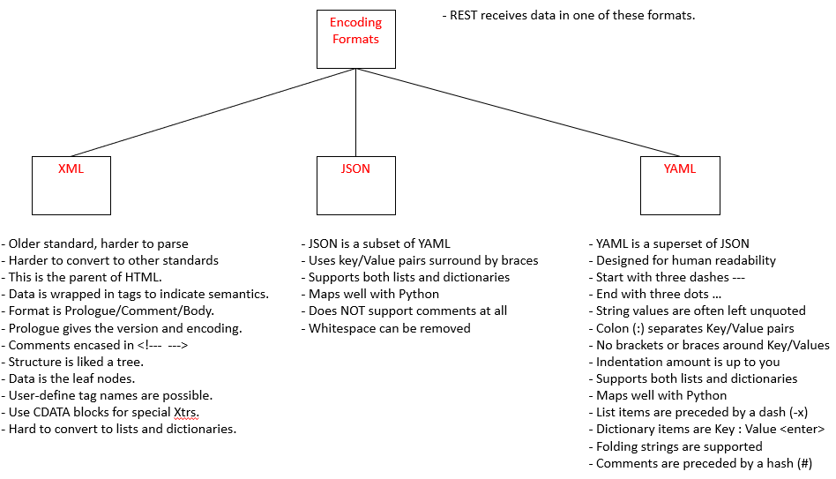

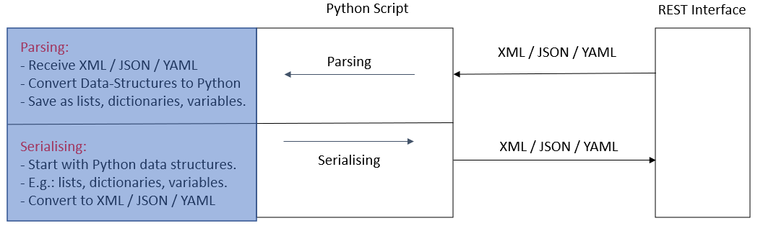
6. Quiz:

1. Which of the following are required attributes of a REST-based API?
Choose two answers.

a. Uses HTTP
b. Objects noted as to whether they can be cached
c. Classful operation
d. Client/Server Architecture

Answer: b, and d.

2. Which answers list a matching software development CRUD action to an HTTP verb that performs that action?
Choose two answers.

a. CRUD create and HTTP PATCH
b. CRUD update and HTTP PATCH
c. CRUD delete and HTTP PUT
d. CRUD read and HTTP GET

Answer: b, and d.

3. Examine the following URI that works with a Cisco DNA Controller:

https://dnac.example.com/dna/intent/api/v1/network-device/managementIPAddress = 10.10.22.74

Which part of the URI, per the API documentation, is considered to identify the resource but not any parameters?

a. https://
b. dnac.example.com
c. dna/intent/api/v1/network-device
d. managementIPAddress = 10.10.22.74

Answer: c

4. Which of the following data serialisation and data modelling languages would be the most likely to be used in a response from a REST-based server API used for networking applications?
Choose two answers.

a. JSON
b. YAML
c. JavaScript
d. XML

Answer: a, and d.

5. Which answers correctly describe the format of the JSON text below?
Choose two answers.

{ “myvariable”:[1,2,3] }

a. One JSON object that has one key:value pair
b. One JSON object that has three key:value pairs
c. A JSON object whose value is the second JSON object.
d. A JSON object whose value is a JSON array.

Answer: a, and d.

6. Which answers refer to JSON values rather than JSON keys as found in the sample JSON data?
Choose two answers.

{
“response”: {
“type”: “Cisco Catalyst 9300 Switch”,
“family”: “Switches and Hubs”,
“role”: “ACCESS”,
“managementIpAddress”: “10.10.22.66”
}
}

a. “response”
b. “type”
c. “ACCESS”
d. The entire grey area

Answer: c, and d.

